4.13 Modify programming problem Exercise 3.13 from Chap.3, which asks you to design a pid manager. This modification will consist of writing a multithreaded program that tests your solution to Exercises 3.13.

You will create a number of threads – for example, 100 – and each thread will request a pid, sleep for a random period of time, and then release the pid.

使用pthread_creat增加100個thread並呼叫先前寫的pid manager給予pid並隨機給予執行時間，呼叫sleep，時間結束後再release the pid。

截圖畫面:

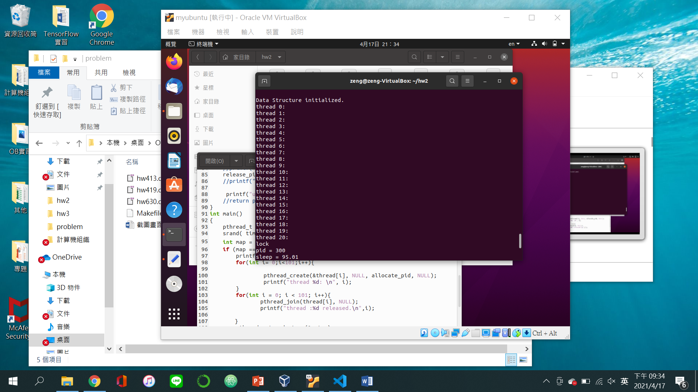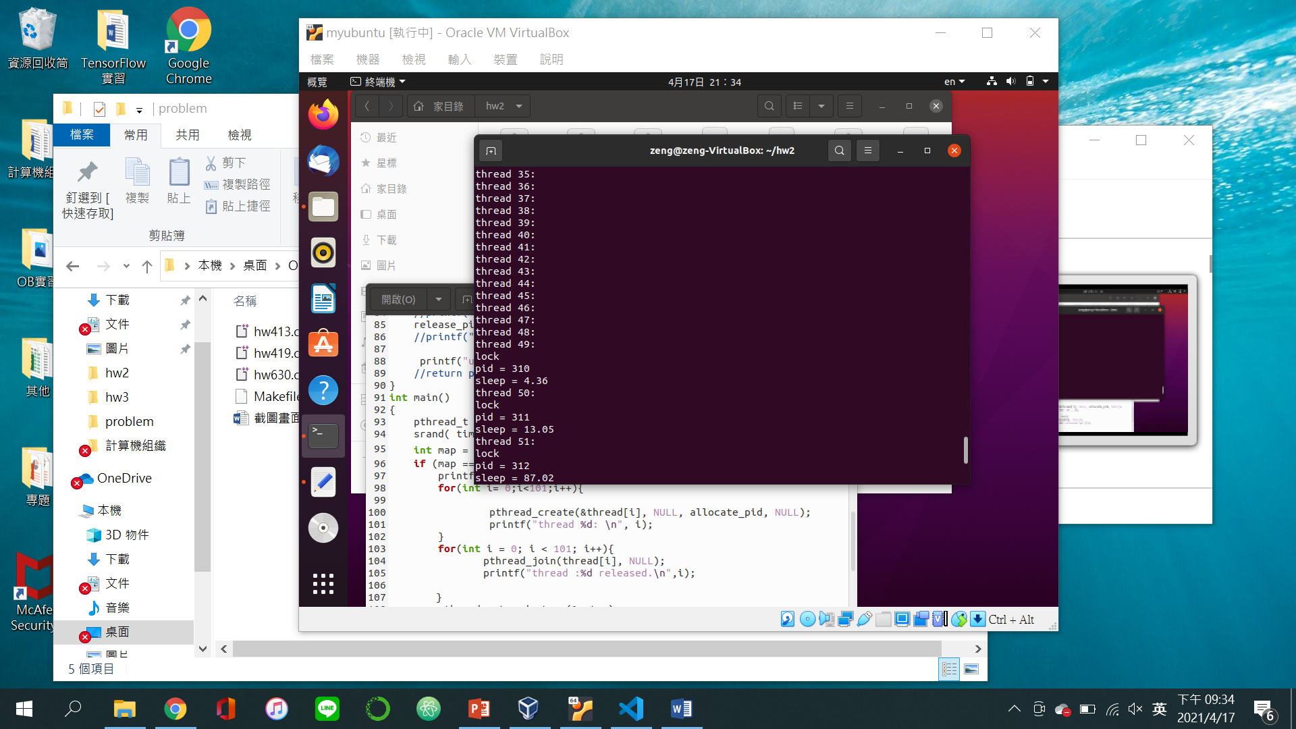

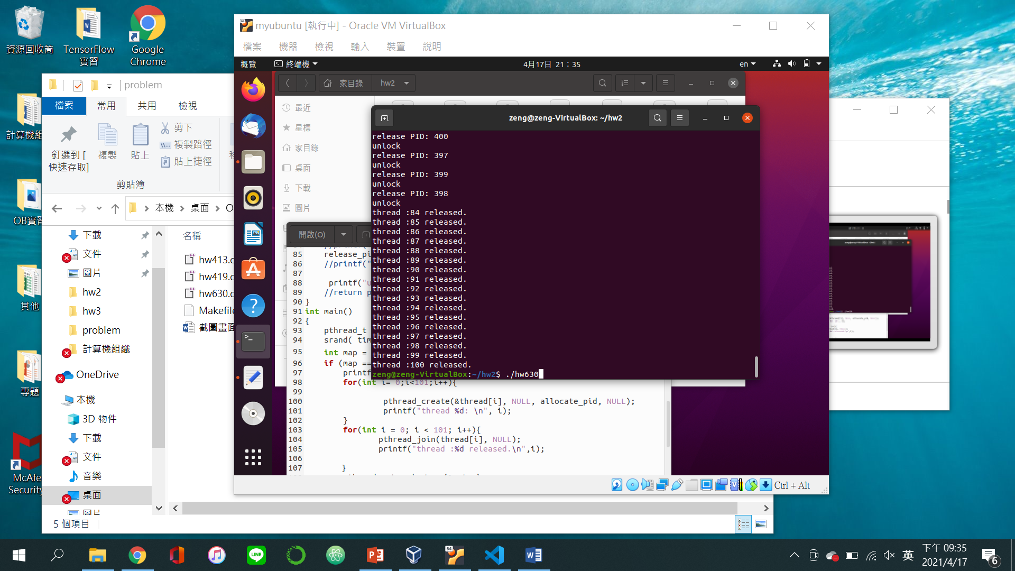

4.19*: Write a multithreaded program that outputs prime numbers. The user will run the program and will enter a number on the command line. The program will then create a separate thread that outputs all the prime numbers less than or equal to the number entered by the user.

使用thread產生一個獨立的thread算出小於等於使用者輸入的數字的質數。

截圖畫面:

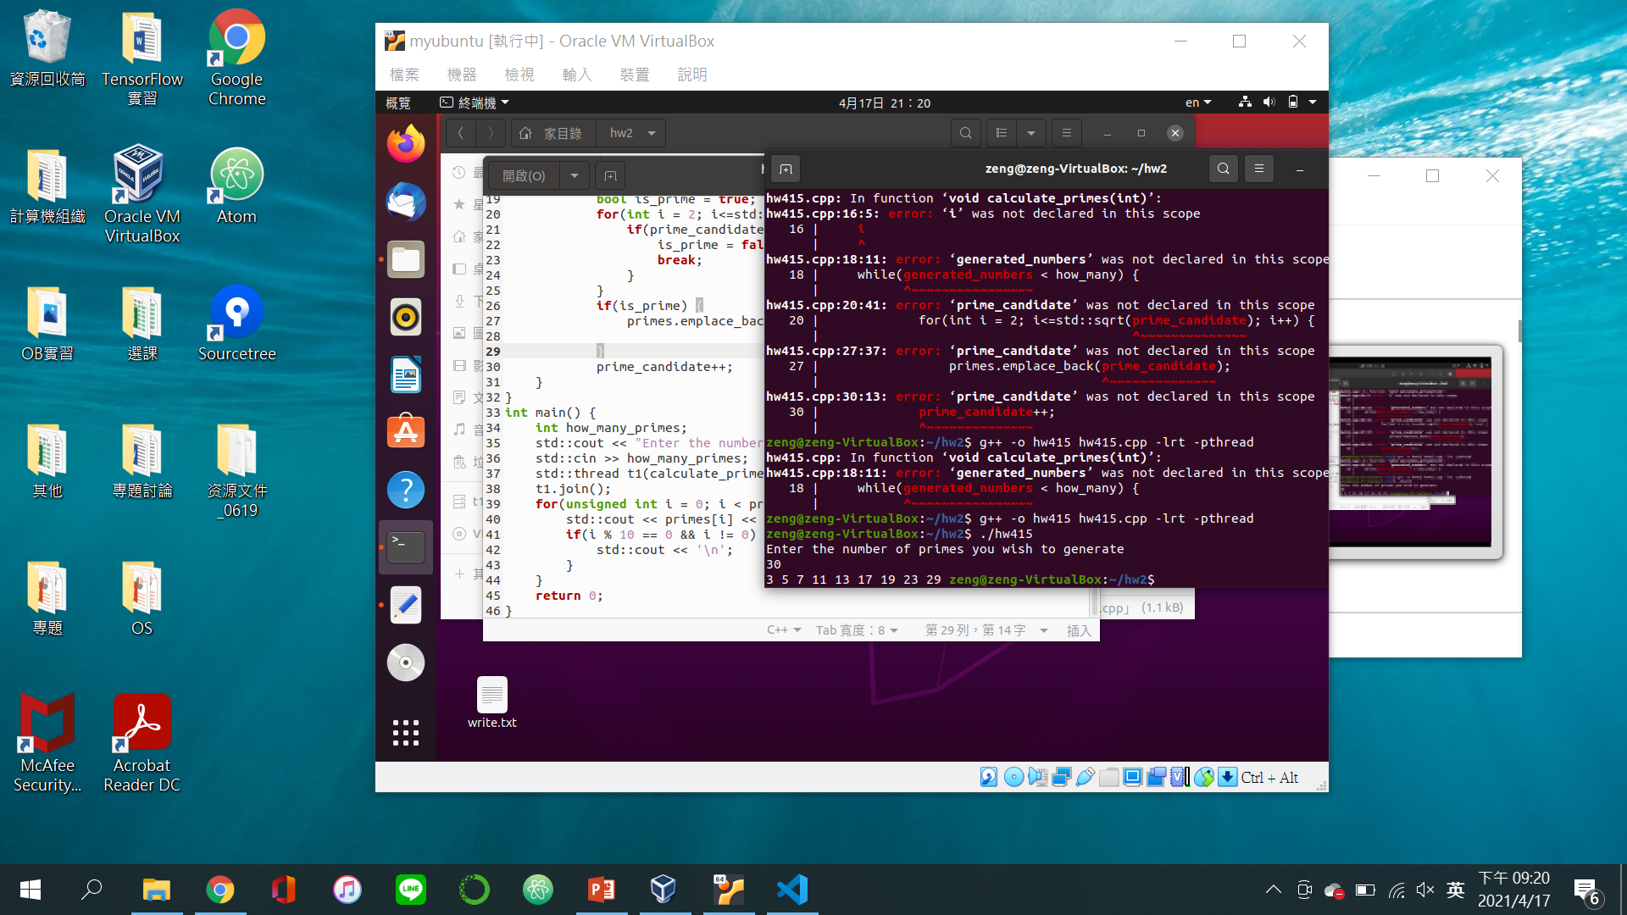

6.30*: Programming Exercise 3.13 required you to design a PID manager that allocated a unique process identifier to each process. Exercise 4.15 required you to modify you solution to Exercise 3.13 by writing a program that created a number of threads that requested and released process identifiers.

Now modify your solution to Exercise 4.15 by ensuring that the data structure used to represent the availability of process identifiers is safe from race conditions. Use mutex locks in Pthreads, Windows threads, or Java threads.

原有的程式架構下加入mutex lock，讓每個pthread不會同個時間進行程序。

截圖畫面:

